Required Capstone Checkpoint 2.1: Retrieval Strategy Design and Baseline Implementation

Directions

You will continue working with the same dataset and scenario you selected for your capstone checkpoint in Module 1. In this activity, you will design and implement a baseline retrieval system that supports the types of queries required for your scenario.

Download this worksheet and save a copy to your device before you begin working. Type your responses directly into the document, save your completed work, and upload the finished file when you are ready to submit.

Use this worksheet to:
- Document your retrieval approach
- Capture representative retrieval queries and results
- Provide evidence that your retrieval system is functioning
- Observe how retrieval performance changes across different query types
- Reflect on where the retrieval approach performs well and where it struggles

1. Selected Scenario and Retrieval Approach
- Identify your chosen capstone scenario.
- Describe the retrieval approach you implemented (keyword-based, semantic, or hybrid).
- Briefly explain why this retrieval approach is appropriate for your dataset and query types.
- Describe any trade-offs you considered when selecting this approach
Scenario
Research Paper Navigator

Retrieval approach used, brief explanation, and description of trade-offs considered
My selected capstone scenario is the Research Paper Navigator, which helps users find academic papers relevant to their research questions.
I implemented a keyword-based retrieval approach. The system converts the query and each paper’s text to lowercase tokens, counts the unique words they share, and returns the top three papers by overlap score. For example, a query about sketch-based program synthesis can retrieve papers containing terms such as “sketch,” “holes,” and “specification.”
Here is the core scoring logic:
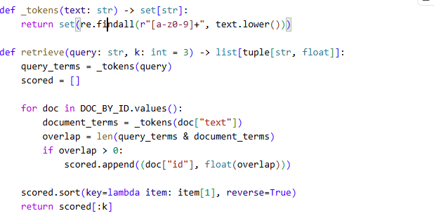
This approach is suitable as a baseline for a research-paper corpus because queries often include technical terms that also appear in paper text. The overlap scores are straightforward to inspect, which helps explain why a paper was retrieved.
The trade-off is simplicity versus understanding. Keyword overlap is fast and transparent, but it treats terms equally and does not understand synonyms or broader meaning. It can miss relevant papers that use different wording or rank a paper highly because it shares query terms without answering the question. A semantic or hybrid retriever could address some of these weaknesses, but would require additional components and evaluation.

2. Baseline Retrieval System Evidence
- Provide evidence that your retrieval system was implemented and tested.
- Evidence may include screenshots, logs, outputs, notebook examples, code snippets, or brief descriptions showing that retrieval queries were executed successfully.
Evidence of retrieval system implementation and testing
I implemented and tested the baseline keyword retriever against the Research Paper Navigator corpus. In the recorded run, the script loaded 151 readable papers and executed five representative queries. For each query, it printed the retrieved document IDs and keyword-overlap scores, then generated an answer using the retrieved paper text.
The retrieval implementation scores each paper by its shared query terms and returns the top three results:
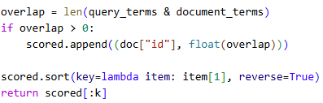
For example, the query “How does sketch-based program synthesis use holes in a partial program to satisfy a specification?” returned:
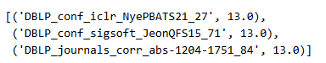
The generated answer identified the JSKETCH paper and explained how it fills holes to satisfy a specification. This terminal output demonstrates that retrieval ran successfully and provided paper text used to answer the query. The script also records successful query results in checkpoint_2_1_retrieval.log.

3. Representative Queries and Retrieved Results
- Provide three to five representative queries relevant to your scenario.
- Include the retrieved results for each query.
- Focus on showing how the retrieval system behaves across different types of information needs. Where possible, include a mix of precise, conceptual, or broader exploratory queries.
Query 1
Query: How does sketch-based program synthesis use holes in a partial program to satisfy a specification?
Retrieved results:
DBLP_conf_iclr_NyePBATS21_27 — 13
DBLP_conf_sigsoft_JeonQFS15_71 — 13
DBLP_journals_corr_abs-1204-1751_84 — 13
Observations: The generated answer identified the JSKETCH paper and explained how a synthesizer fills holes to satisfy a specification. This precise, technical query retrieved relevant material. The three results tied, showing that the overlap score does not distinguish between equally matching papers.

Query 2
Query: Which papers describe synthesizing programs from input-output examples or formal specifications?
Retrieved results:
DBLP_conf_icml_GuJLSESS25_31 — 11
DBLP_journals_cacm_AlurSFS18_81 — 11
DBLP_conf_mapl_GottschlichSTCR18_40 — 10
Observations: The answer discussed multiple papers and techniques, including programming by example and input-output examples. This broader query returned several useful candidates, demonstrating multi-paper coverage. However, the equal or similar scores do not show which paper is most useful for each part of the question.

Query 3
Query: How do synthesis methods search candidate programs and check whether they meet the desired behavior?
Retrieved results:
DBLP_conf_cidr_CheungAMSM13_16 — 14
DBLP_conf_iclr_NyePBATS21_27 — 14
DBLP_conf_icml_AletLKNSLKT21_29 — 14
Observations: The answer described searching partial programs and checking candidates against specifications or examples. The results included relevant synthesis papers, but also a paper about query extraction. This illustrates a limitation: shared vocabulary can produce a high-scoring result that is not directly relevant.

Optional Additional Queries
Query: How can a computer automatically complete missing code based on examples of the intended behavior?
Retrieved results:
DBLP_conf_icml_TavaresK0DS21_37 — 14
DBLP_conf_cidr_CheungAMSM13_16 — 13
DBLP_conf_cikm_CheungSM12_17 — 13
Observations: This query used different wording from “program synthesis,” but still retrieved papers discussing synthesis from examples and specifications. It shows that the baseline can handle some wording variation when terms overlap. Its scores are still lexical, so more indirect synonyms may be missed.

4. Retrieval Performance Reflection
- Reflect on where your retrieval approach performs well and where it struggles.
- Consider how different query types affect retrieval quality, relevance, flexibility, or precision.
Retrieval strengths
The retriever worked well for specific technical queries that used terms found in the papers. For example, “How does sketch-based program synthesis use holes in a partial program to satisfy a specification?” returned three papers with overlap scores of 13. The generated answer identified JSKETCH and explained how it fills holes to meet a specification.

It also handled a paraphrased query: “How can a computer automatically complete missing code based on examples of the intended behavior?” returned papers about program synthesis. This suggests the baseline can handle some wording variation when meaningful words still overlap.

Retrieval limitations or challenges
The query “How do synthesis methods search candidate programs and check whether they meet the desired behavior?” returned relevant papers, but also DBLP_conf_cidr_CheungAMSM13_16, which discussed query extraction. This is an example of a high-overlap result that was not directly relevant.
The three results for the sketch-based query all scored 13, so the score did not distinguish their relevance. This happens because the baseline counts shared unique words equally and does not understand context or term importance. It also returns only three papers, and extracting only the first eight pages may miss information later in a paper.

Patterns observed across different query types
Precise queries with distinctive terms, such as “holes” and “specification,” tended to retrieve useful papers. Broader queries returned multiple possible sources, but sometimes included less relevant results. The paraphrased code-completion query still found relevant papers, though the system relies on word overlap rather than understanding that “complete missing code” relates to program synthesis.
Overall, the examples show that keyword overlap is a transparent baseline for terminology-matched searches, but its scores indicate lexical similarity, not guaranteed relevance.

5. Retrieval Strategy Reflection
If you were continuing to improve this system, would you keep the same retrieval approach or make changes? Explain your reasoning.
Reflection
I would keep the current keyword-overlap retriever as a simple, transparent baseline, but I would improve the system with a hybrid approach. The tests showed that keyword overlap can find relevant papers when query terms match the paper text, but it can also return loosely related results and cannot reliably handle synonyms or different wording.
A next version could combine BM25 keyword ranking with semantic embeddings, then compare its results against this baseline using the same representative queries. I would also evaluate relevance and refine document extraction or chunking so the system can find useful information throughout each paper. This preserves a reproducible point of comparison while addressing the main limitations observed in testing.
Run Code:
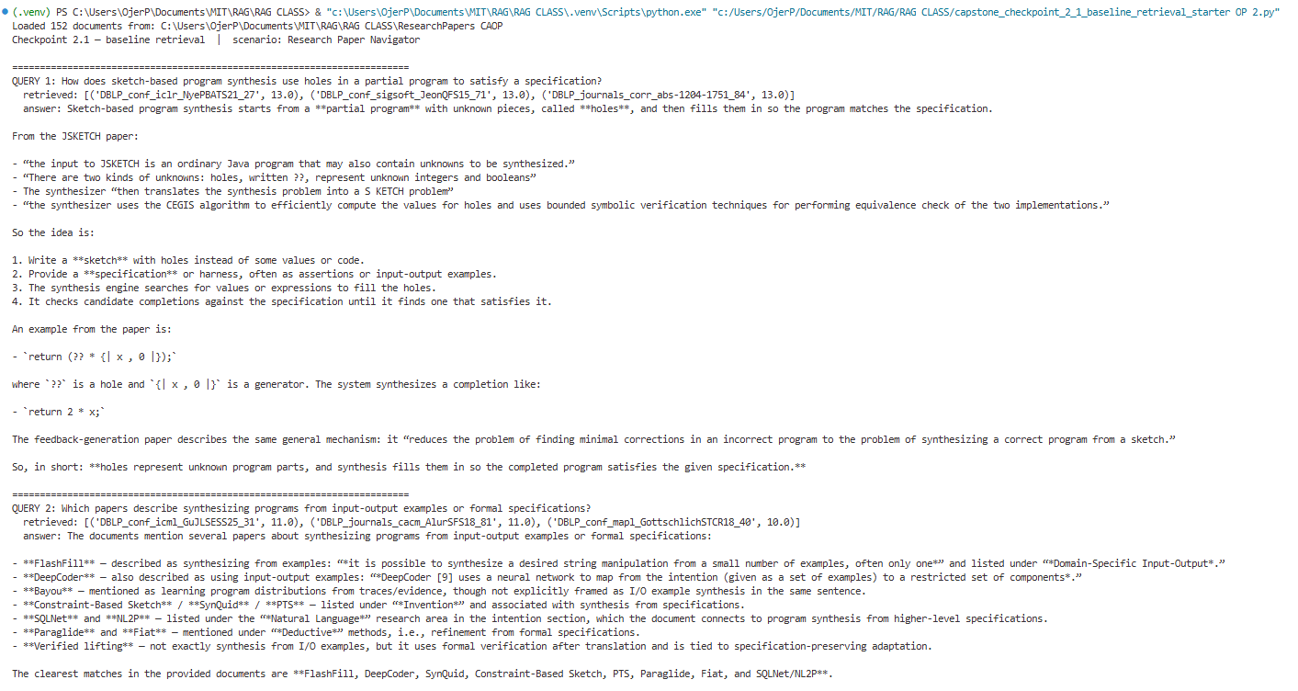
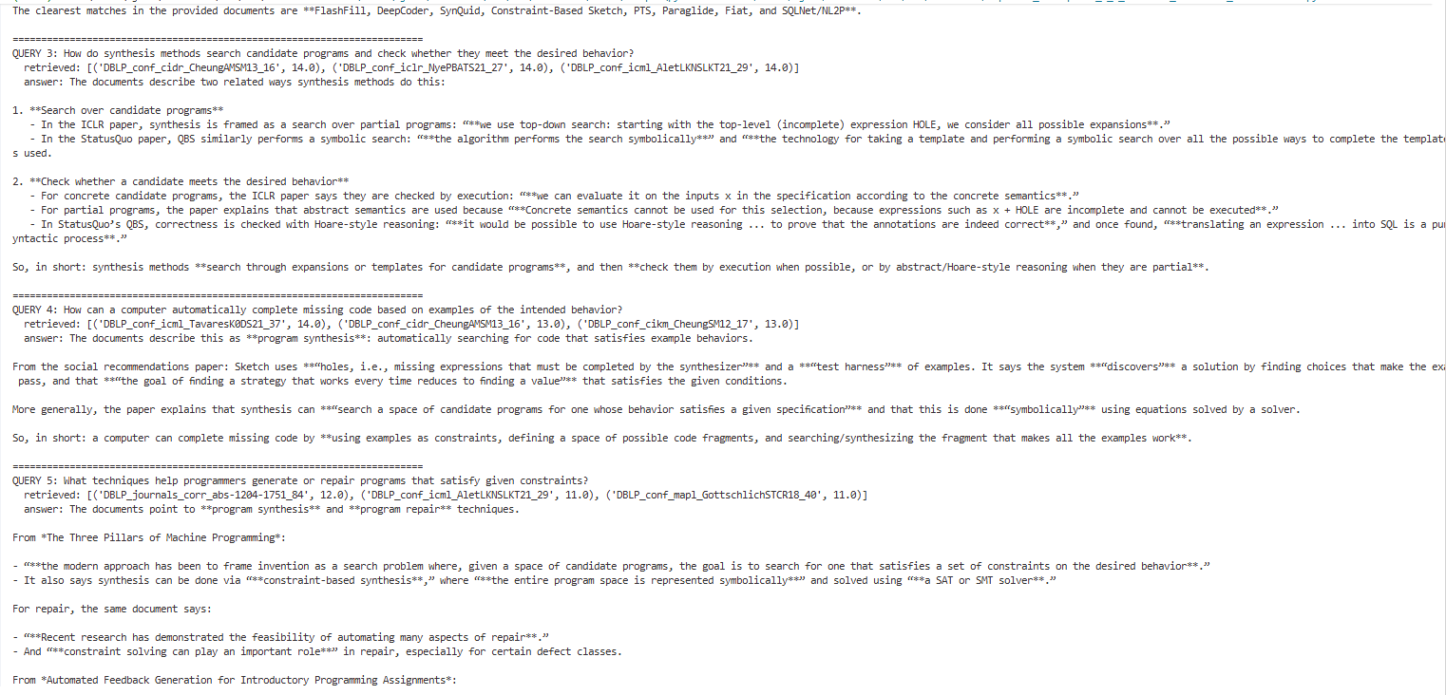
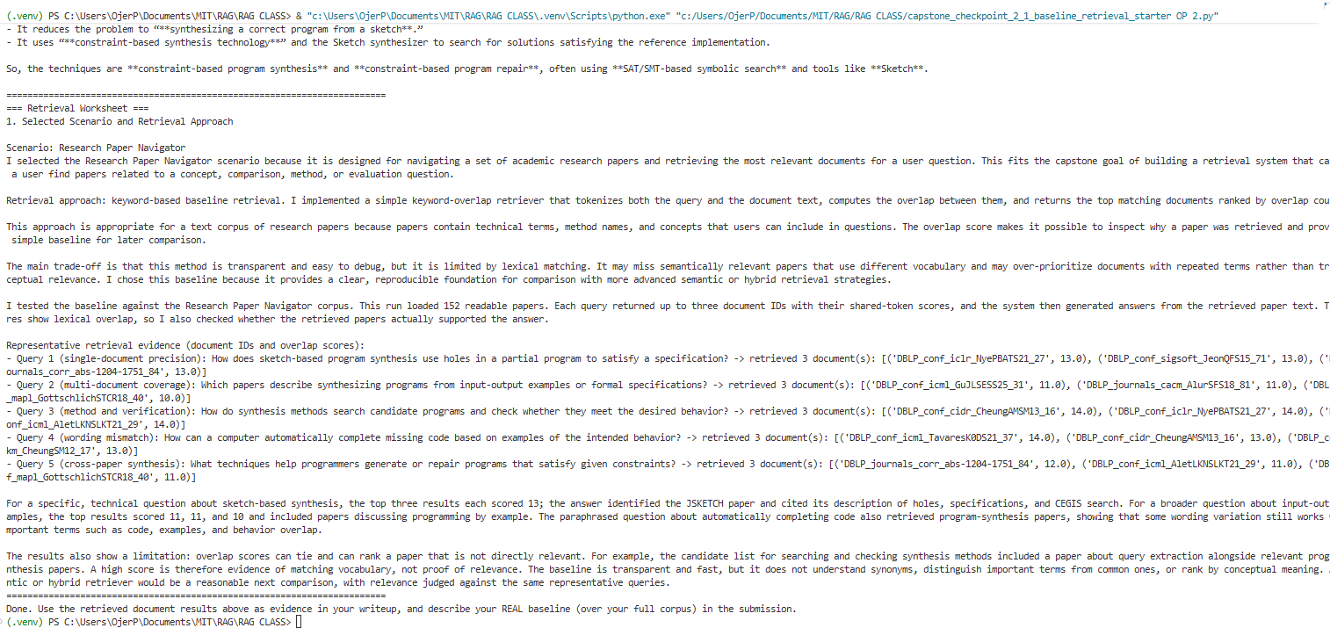

Supporting Materials
Additional Evidence (Optional):
If needed, include any additional screenshots, output excerpts, or code snippets that support your responses above. No additional files or repository link are required for this checkpoint.

End of Required Capstone Checkpoint 2.1
Return to the assignment page in the learning platform to upload and submit your completed capstone checkpoint and complete any remaining items in this module.

